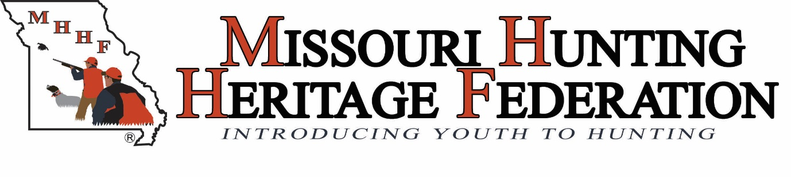
Hunter Ed Instructor/Mentor Rendezvous
Sunday, April 19, 2015
Meeting Notes

MHHF Hunter Ed Instructors and Mentors gathered to share their experiences executing the MHHF Clinic Model. The goal was to learn from each other, identify best practices and explore ways to improve the clinic model for everyone involved.
These notes reflect the outcome of their discussion.

PRE-CLINIC PREP:
- Have a contingency plan in the event of inclement weather, mentors/instructors unexpected illness, alternate locations, & additional mentors specifically identified. All positions have a back-up (clinic organizer, instructors & mentors).
- Publish a full volunteer (mentors/instructors/land owner/other volunteers) list with phone numbers. Clinic organizers need to be able to call mentors during the day if needed.
- Print roster from Hunter Education online class registrations several days ahead of as the Missouri Department of Conservation numbers are generated in advance of the clinic.
- Communicate well in advance to land owner & dog handlers (even if we have worked with them before) so everyone is clear of expectations. Try to rotate landowners and not exhaust resources. Reach out to create more resources.
- Print off and pass out hard copy maps of the hunt location to mentors and students at the end of the classroom or live fire session. Global Position System (GPS) aren’t always accurate.

CLASSROOM:
- To enable instructors to learn student’s names, print table tent name signs for classroom and name tags for skills portion in advance.
  - Large Text
  - Name tags for both youth, parents/chaperones and instructors
- Print out registrations and distribute to participants at the beginning of the class. Check registration with participants (spelling, contact info, etc.), make corrections as needed.
- If the first time the group meets is the skills portions, consider implementing an ice breaker exercise that includes a knowledge portion review. This is to encourage the group to get to know each other and feel comfortable speaking up.
- Distribute handouts only when ready for discussion (of the hand out) to ensure class attention stays focused on current lesson.
- Under supervision, encourage students to handle the demo firearms during breaks.
- Practice the formation that the participants will be executing for both the live fire and the hunt before going out to actual situations.
  - Stance
  - Proper handling of firearm
  - How to load
  - What to do if firearm jams
- Review and practice safe formations while hunting with others in a field prior to live-fire.

HUNT:
- Add a step to check licenses the morning of the hunt to the check list.
- Conduct a Mentors-only safety talk before hunt to review procedures.

MISC:
- Write down the comments from the participants to chronical the funny things they may say to capture the essence of their experience. These could be used as testimonials or fun anecdotes for MHHF website or social media.
- Acquire a 410 shotgun. Some students aren’t able to handle the larger gauge gun.
- Consider having the Mentor carry the license during the hunt.
- Purchase MHHF branded license holders for youth to use during the clinic weekend and to keep.
- Move checklists to the Best Practices section of the manual.
- Make a point to ensure that the surface you use to project the video or presentations will provide a clear image. MHHF has a projector screen available.
- Have some cold weather gear (coats, gloves, sweatshirts, etc.) available for youth participants.
- Send a message well in advance of the clinic to parents about proper clothing.
- Bring essential toiletries for any pit stops in the woods (including those geared towards our female participants). Put in a ziplock baggie to keep dry.
- Mentors bring extra clothes (orange, camo, gloves) for youth to borrow.
- Reach out to manufacturers, sponsors, MDC, etc. to ask them for vests, duck calls, etc. with their logos. (turkey calls, too).
- Target more select groups to market for participants. (Tailor the program specific to the group).
- Develop training session for mentors (veterans and new recruits).
- Suggest reviewing all the info from this meeting at the annual meeting.

